**(2 Point)** You are given an interface named **Convertible (DO NOT CREATE THIS ONE)**. Design a class **MyConvertible** which will implement the interface Convertible.

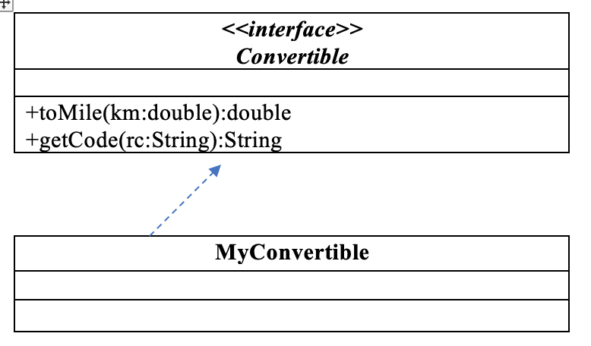

1. double toMile(km:double) – used to convert a km value to mile value. *Given 1km = 0.621371 mile*

2. String getCode(rc:String) – assuming that length of Reservation code is dividable by 3 ; this function return code of RC as the rule:

* Code of RC = separate a RC into groups, each group has exactly 3 characters with same order of orginal RC, groups are seperated by character “-“, eg A12-BE2-CM5

The program output might look something like:

| **No of test case** | **Correct output** |
| --- | --- |
| 1 |  |
| 2 |  |